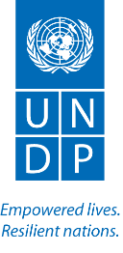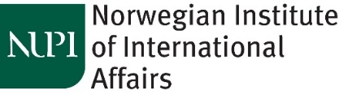

**PDA Fellowship Programme – 2nd Cohort**

**19 – 30 June, 2017: Oslo, Norway**

***Promoting Local Ownership and Building Capacities for Conflict Prevention***

**Profile of the participating Fellows**

**Agyenta Anthony** is the outgoing PDA in Kenya where he headed the UNDP Program development on community security, social cohesion, and resilience. He supported the UN system country analysis, information management and the UNDAF processes to incorporate conflict dimensions and innovations and promoted national ownership of peace architectures. In the lead up to Kenya’s 2017 elections, he promoted an integrated approach incorporating prevention and response to risks of violence and political tensions.

In the past, Anthony has served in the South Pacific region as the UN Chief Technical Adviser for multilateral support to post conflict stabilization and recovery; first in Papua New Guinea’s autonomous region of Bougainville from 2009- 2013, before he moved into the Solomon Islands to provide advisory support to the national dialogue and unification roadmap under a UN joint programme support through the office of the Prime Minister.

Prior to his work with UNDP, Agyenta also served in UN Peace Missions in the capacity of Civil Affairs Team Leader in Sierra Leone (2002-2006), and in the Sudan (2006-2010). Anthony holds multiple degrees from leading institutions in Politics of Alternative Development Strategies; Development Economics; Strategic Management and a BA (Hons) French and Political Science (University of Ghana).

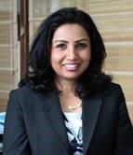**Archana Aryal** is thecurrent Team Leader, Democratic Transition Unit in UNDP Nepal where she oversees the implementation of UNDP’s transition projects in the country and monitors all aspects relevant to the implementation of the Comprehensive Peace Agreement and issues relevant to Nepal´s transition.

With more than a decade experience of working in conflict prevention and peacebuilding in Nepal she has experience of analysis of political, social and economic trends related to peacebuilding, giving policy advice and programme / project management etc. While in UNDP she has had experience of managing two Programmes: one related to Conflict Prevention and the other which was a UN Interagency Rehabilitation Programme (with ex-combatants) involving UNDP, UNICEF and the UN Resident Coordinator’s Office for mainstreaming conflict sensitivity. In this, she took a lead in incorporating conflict sensitivity within the UN system, with an initial focus on key initiatives within UNDP, UNICEF and the RC’s office while also connecting with key government counterparts.

She has authored a research-based publication “*Bullets to Ballots: Participation of Maoist Women in the Parliament and the Government of Nepal after the People’s Movement 2006*”. She has previous working experience with CARE International Nepal and ActionAid Nepal. She holds an MA in Development Studies, with specialization in conflict, reconstruction and human security from the Institute of Social Studies, The Hague, The Netherlands.

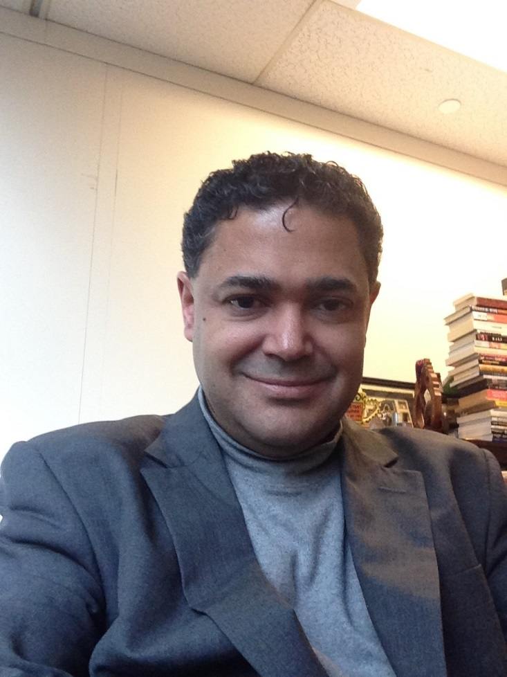**Chetan Kumar** is Senior Advisor on Peacebuilding to the UN Resident Coordinator and to UNDP in the Philippines where he focuses on bringing lasting peace and stability to conflict-affected areas in the Mindanao region of the Philippines. Over the past fifteen years, he was worked in building national and local capacities for the prevention and resolution of conflicts, the promotion of dialogue, and the constructive management of diversity through the reform of governance initiatives in twenty-one countries in Asia, Africa, and the Caribbean, including in Haiti, Guyana, Ghana, Zimbabwe, Kenya, Lesotho, Malawi, Nepal and the Philippines.

Previously he headed UNDP’s Conflict Prevention Team in New York. From 2004 to 2012, he developed, initiated and managed the Joint UNDP-DPA Programme on Building National Capacities for Conflict Prevention, through which PDA’s are deployed by UNDP and the UN Department of Political Affairs to support the development of national capacities and initiatives for dialogue and for conflict management.

Prior to joining UNDP in 2002, he had worked for the Office of the Special Representative of the UN Secretary-General for Children and Armed Conflict; the International Peace Institute in New York; and the Programme in Arms Control at the University of Illinois. He holds a Ph.D. in Political Science from the University of Illinois at Urbana Champaign in the United States.

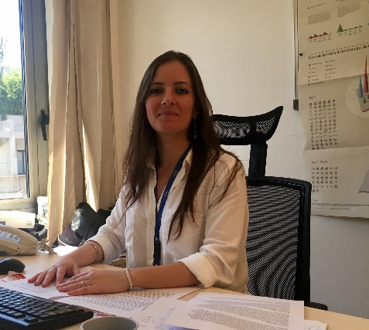**Joanna Nassar** has been working with UNDP Lebanon since 2007: first with the Technical Assistance to the Lebanese Palestinian Dialogue Committee at the Prime Minister’s Office providing technical support and advice to the Lebanese government on the improvement of Palestinian refugees’ living conditions in Lebanon and the Lebanese Palestinian relations and dialogue followed by the Peace Building in Lebanon project which she has been managing since 2013. In her current position, she designed (based on brief conflict assessments she conducted) a number of interventions targeting local authorities, government staff, local actors, as well as educators, aiming at building national skills for conflict prevention, dialogue and reconciliation efforts in the country.

She has also been providing input to UNDP Country Office on key peace building and social cohesion issues. She also sits on the Lebanon Social Stability Working Group which gathers all parties from the international community dealing with the Syrian crisis response. She has experience designing and implementing joint UN programs and taking part in joint reflections, including working with the Resident Coordinator's office. Lately she has been engaged in the discussion at the UN country team level on PVE agenda for Lebanon.

Since January 2016 she was included in the UNDP Roster for National Experts on Peace and Development and in the same year, appointed to sit on the Advisory Board for the Arabic Peace Building Toolbox for UNDP Sudan. She has conducted detailed assignments to UNDP Islamabad office and to UNDP Amman Regional Hub.

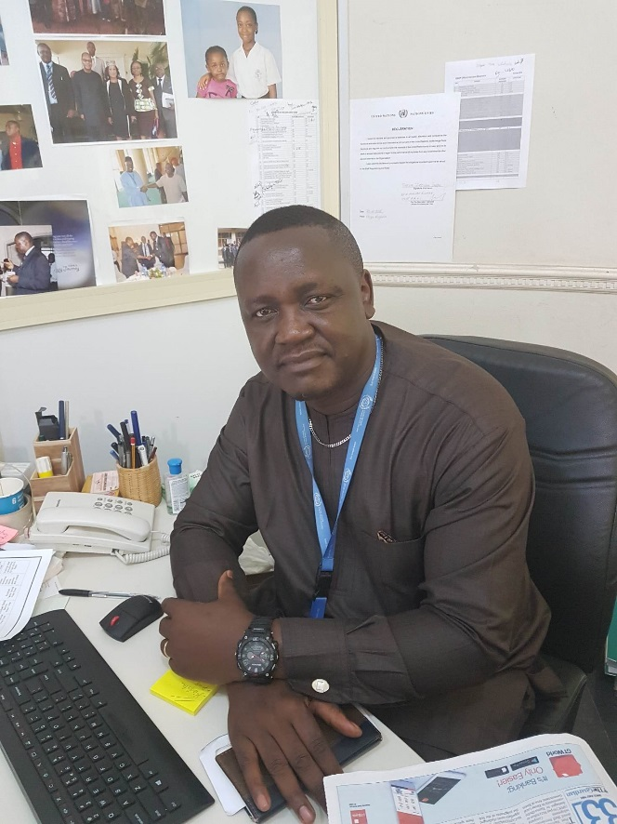**Takwa Zebulon Suifon** joined the UN in Nigeria as the PDA to the Resident Coordinator and the UN Country Team in July 2014. He collectively worked as part of a team to ensure peaceful general elections in Nigeria in 2015 apart from providing technical support in the establishment of the National Peace Committee and providing analysis and recommendations on ways to resolve the Boko Haram insurgency. He led the Governance and Peacebuilding component, on behalf of the UN, of the joint Recovery and Peace-Building Assessment (RPBA) of the North-East of Nigeria by the UN, World Bank and the European Union.

Before this Takwa has served close to 5 years with the African Union (AU) Commission (based in Addis Ababa) where he headed the continent-wide Post-Conflict Reconstruction and Development efforts. Prior to that, he served as Liaison Officer to the Economic Community of West African States (ECOWAS) in Abuja, Nigeria, a position he combined with his functions of Early Warning and later Director of Programmes of the West Africa Network for Peacebuilding (WANEP).

Takwa has more than 15 years of professional experience, a greater part of which has been devoted to issues of early warning and conflict prevention; peacebuilding, mediation and conflict/crisis management; post-conflict reconstruction and linking development, governance and peace/security in Africa. Besides being a practitioner, he serves as faculty in many institutions and training centres in Africa such as Fellow, Society for Peace Studies and Practice (SPSP), Peace and Conflict Studies, University of Ibadan, Nigeria.He has published in journals, contributed to book chapters and is currently working on many manuscripts for eventual publications. Takwa holds a PhD in History from the University of Yaoundé I (where he also had his BA and MA in History) and is Cameroonian by nationality.

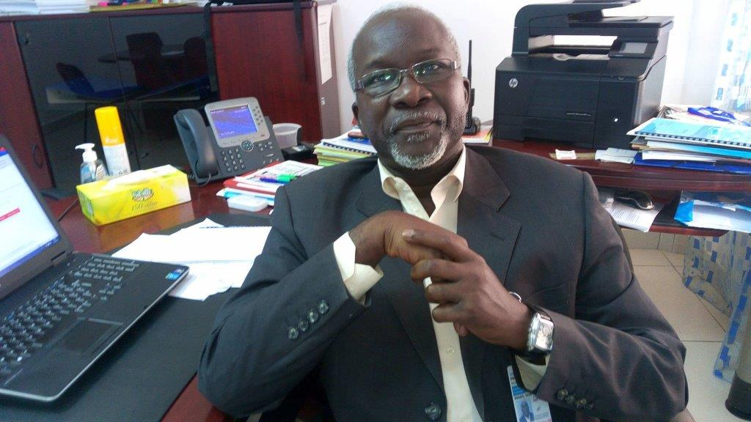

**Waly Ndiaye** is the PDA with the UN in Guinea since January 2016. His major efforts, are focused on the regular provision of thorough political analyses and support to the RC and the UNOWAS SRSG’s facilitation mission in Guinea, the monitoring of the implementation process of a key political agreement reached in October 2016 after 3 weeks’ inclusive dialogue he contributed to facilitate. As the head of the Peace Building Fund portfolio, he initiates and leads an ongoing conflict analysis process, with the purpose of building a National Infrastructure for Peace, strengthening citizenship and national cohesion, through a limited number of very relevant peacebuilding projects.

Within the context of the UNDAF roll-out process, he supports the UNCT in its efforts to implement the “Delivering as One” policy of the UNDG and to smoothly mainstream the principles of sustaining peace in the achievement process of the SDGs.

Prior to his posting in Guinea, Waly has been working as PDA since 2009, successively in Guinea-Bissau and Comoros, with several detailed assignments in Mauritania, Togo, Chad, Madagascar. Before joining the UN, Waly worked as Senior Governance Adviser for SNV (Netherlands Development Organization), as a Director of Programs for the Goree Institute, among other positions.

During his more than 20 years’ professional life, he supported several national consultative processes and mediation initiatives, facilitated conflict transformation workshops and run many capacity building workshops in Strategic Planning, leadership skills developments, etc.